**EXPERIMENT AND RESULTS**

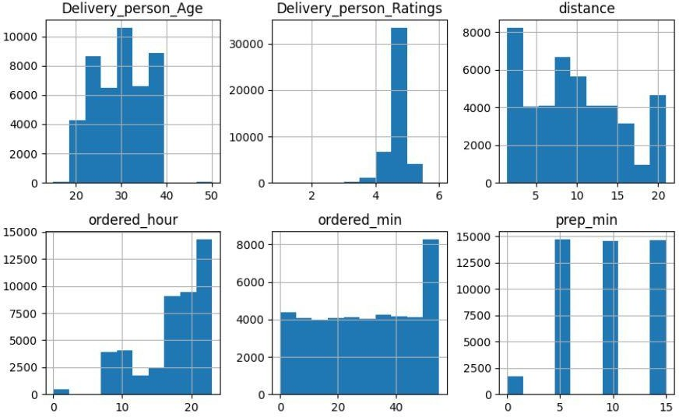

Histogram of Numerical Features in our dataset

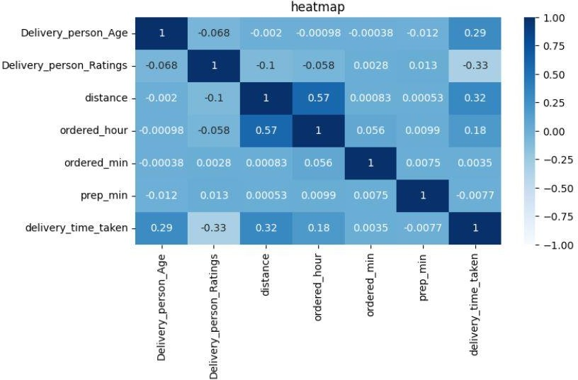

Heatmap of the Numerical Columns

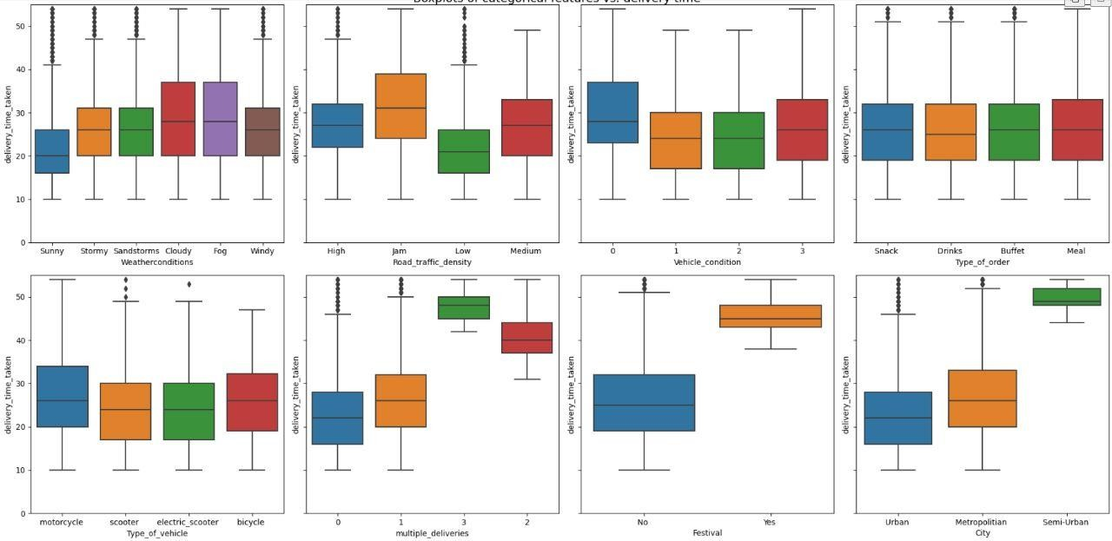

Boxplot of Categorical Columns vs delivery time

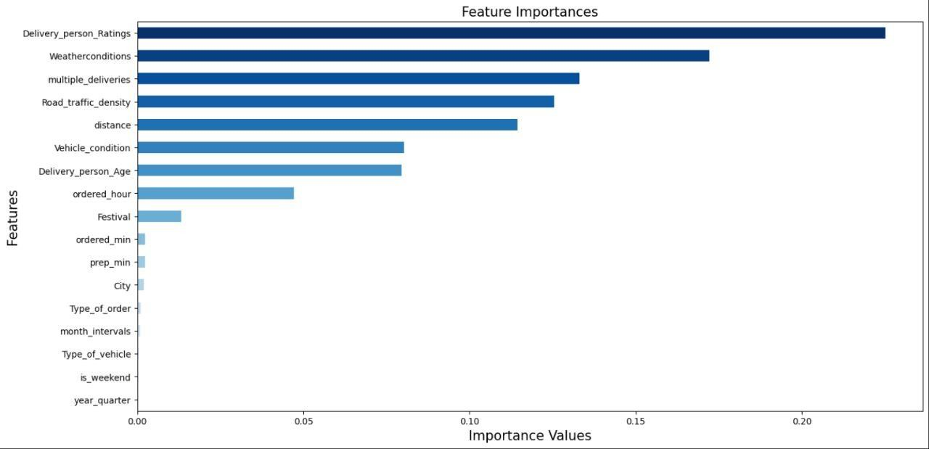

Feature Importance Graph for the given attribute